Create Flask Project

|  |  |
| --- | --- |
| Date | 2 November 2022 |
| Team ID | PNT2022TMID48482 |
| Project Name | Personal Expense Tracker Application |

**Step 1 -** Install Python latest version from python.org

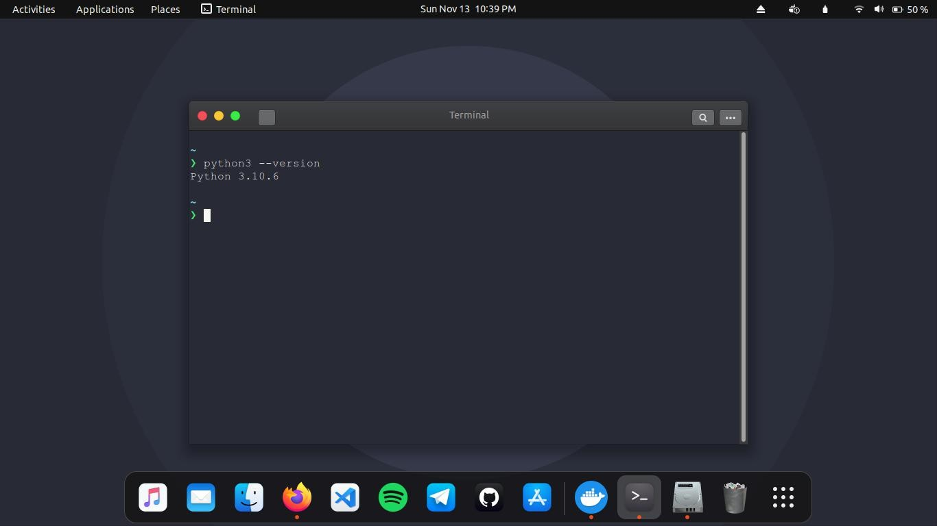

**Step 2 -** Install Flask using command pip install flask

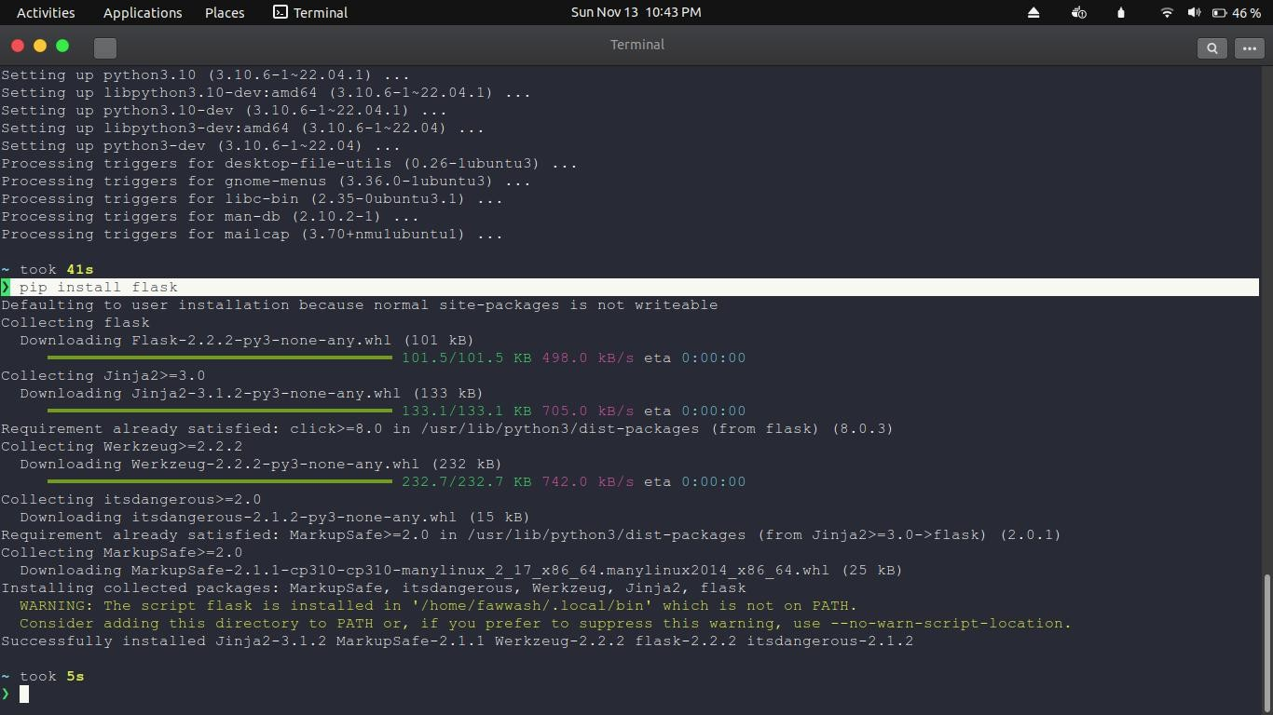

**Step 3 -** Open a new Python file and start coding

from flask import Flask app = Flask( name ) @app.route("/")

def home():

return "Hello, Flask!"

if name == ' main ': app.run(debug=True)

**Step 4**. Run the Python file using command python3 app.py and Open the Ip in browser

